**API’**s

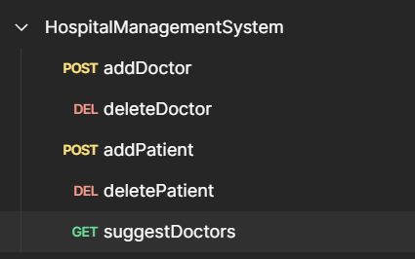

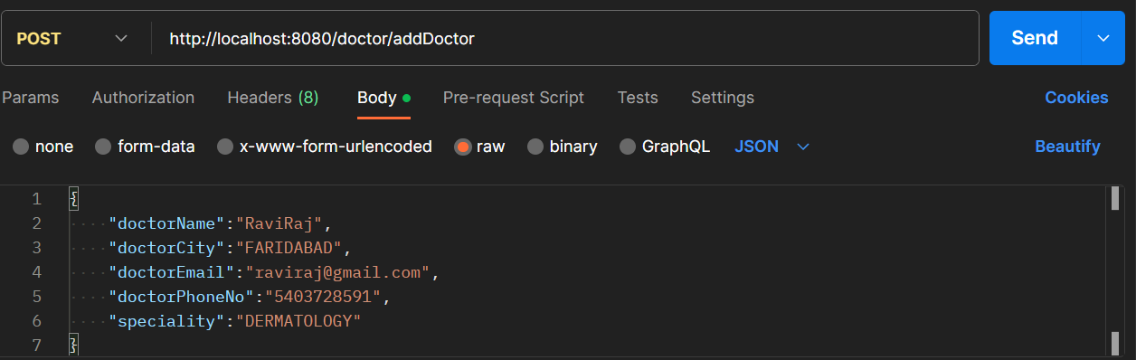**AddDoctor API**

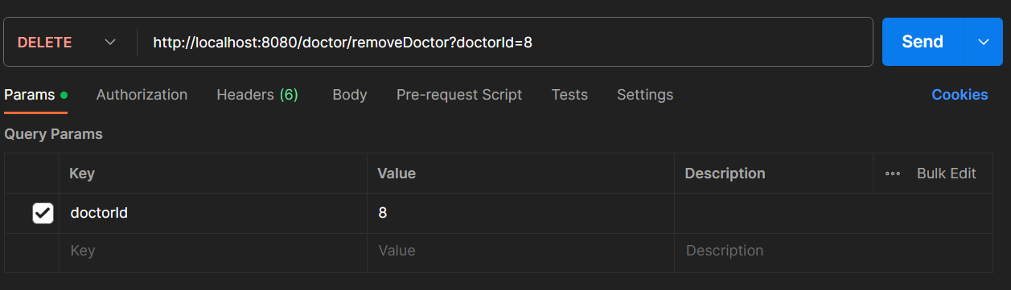**Delete Doctor API**

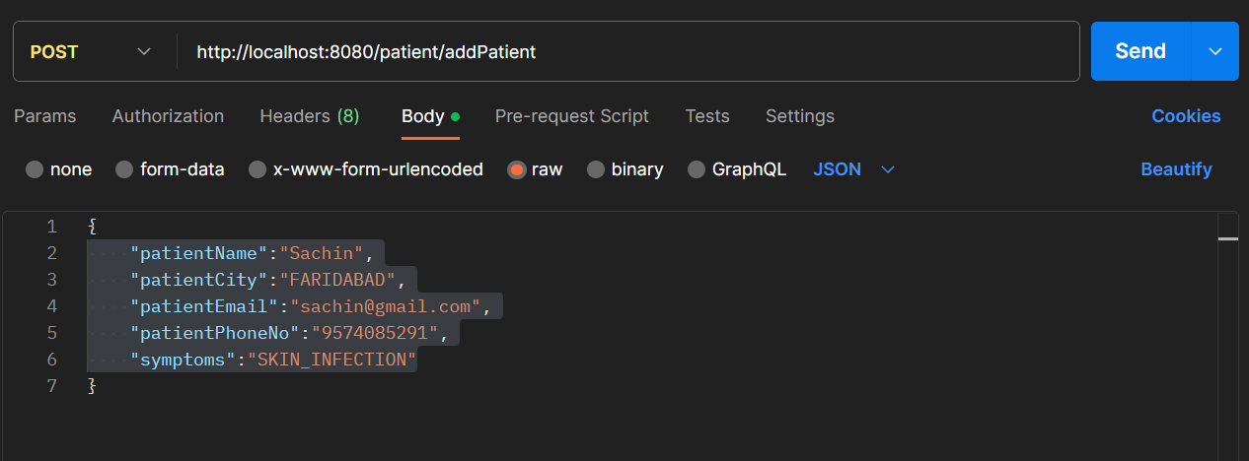**Add Patient API**

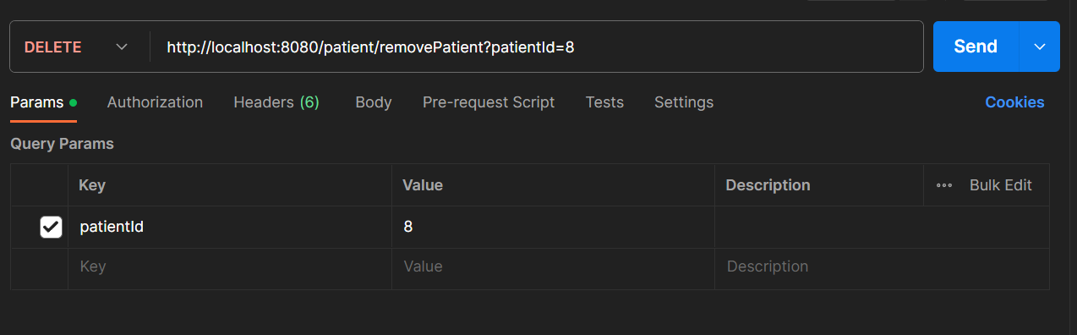**Delete Patient API**

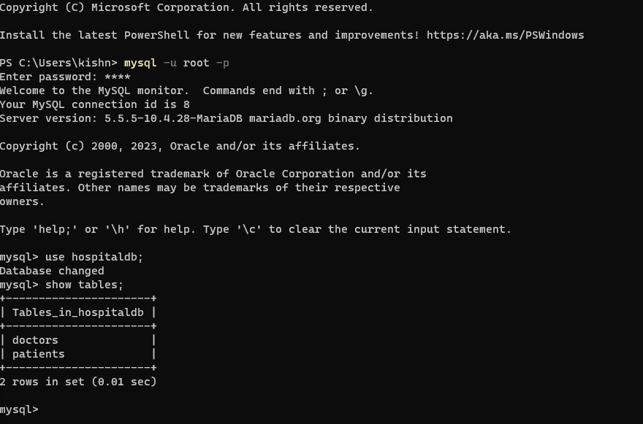**Hospital DB Tables**

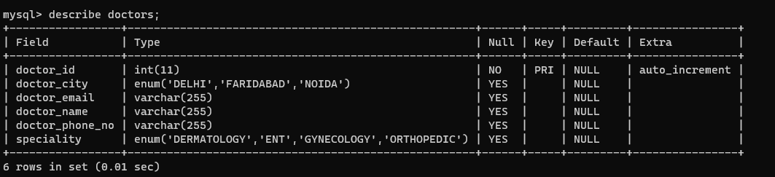**Description of Doctors DB**

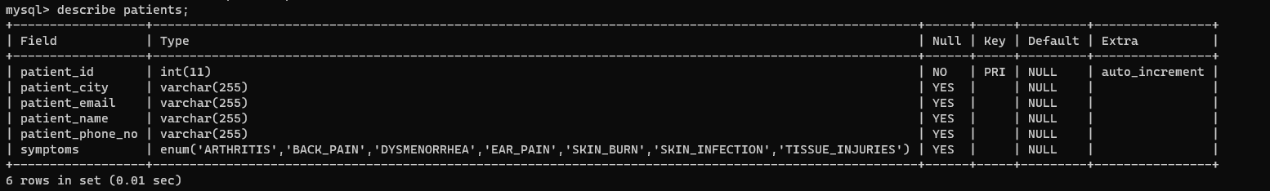**Description of Patients DB**

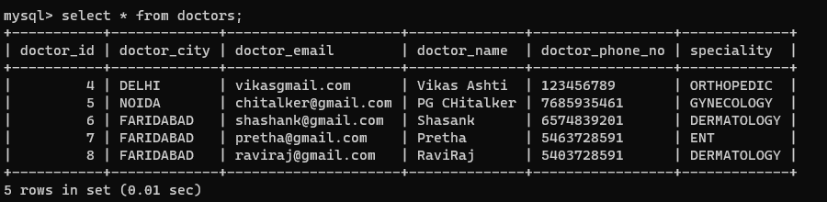**After Adding Doctors In DB**

**After Adding Patients In DB**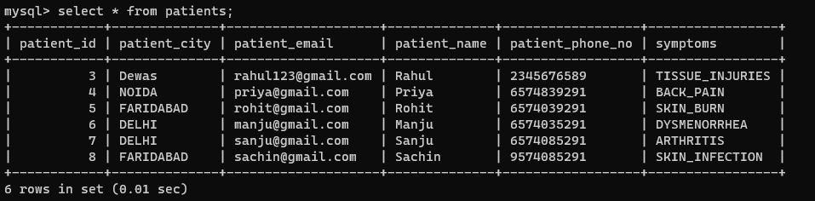

**After Deleting the Doctor In DB with Id**

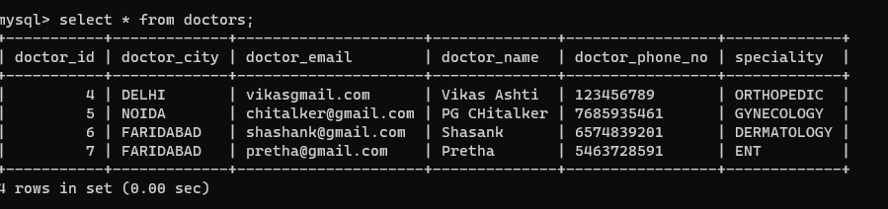

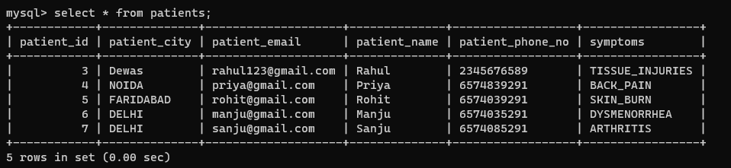**After Deleting the Patient In DB with Id**

**Suggesting Doctor API**

**Check in both doctors and Patients Db**

**With patient id**



**Edge Case 1 :- Location not matched**

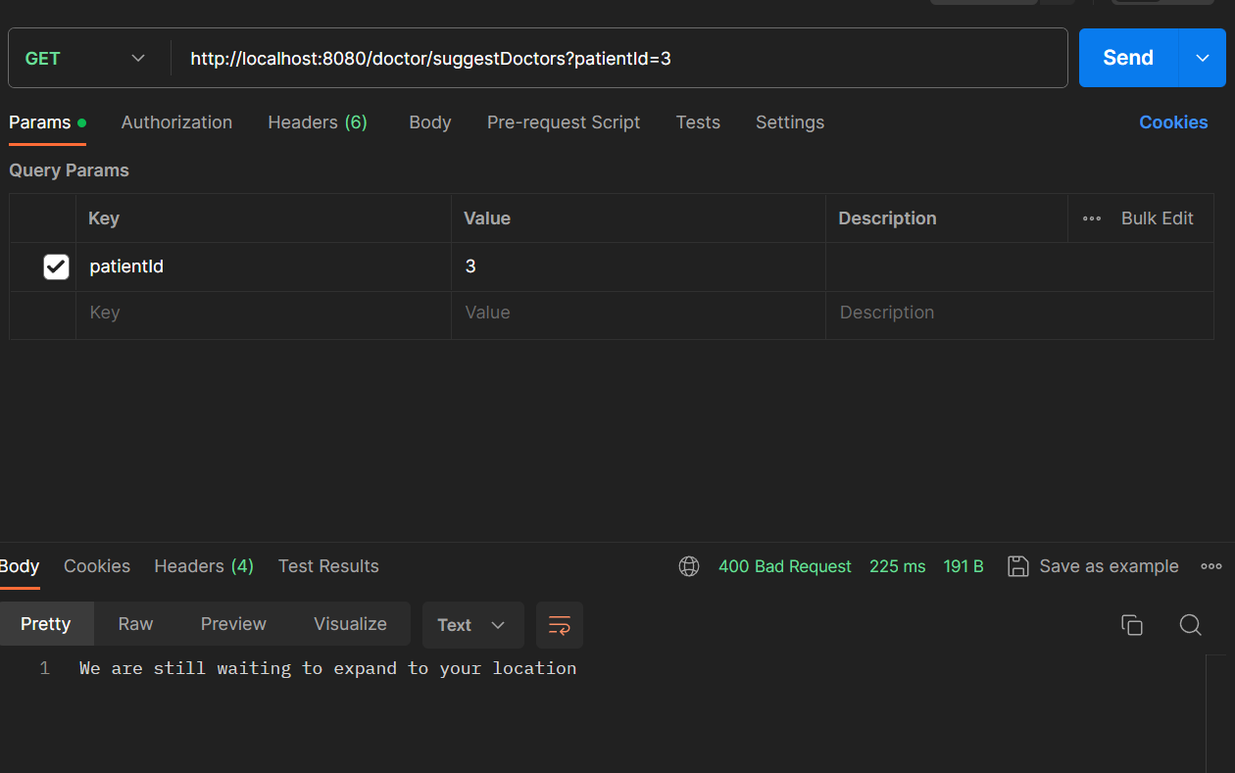**Check the patient whose Id is 3 has any doctor match with the location and doctor speciality**

**Edge Case 2:-Location matched but isn’t**

**Any doctor present your location for patient symptoms**

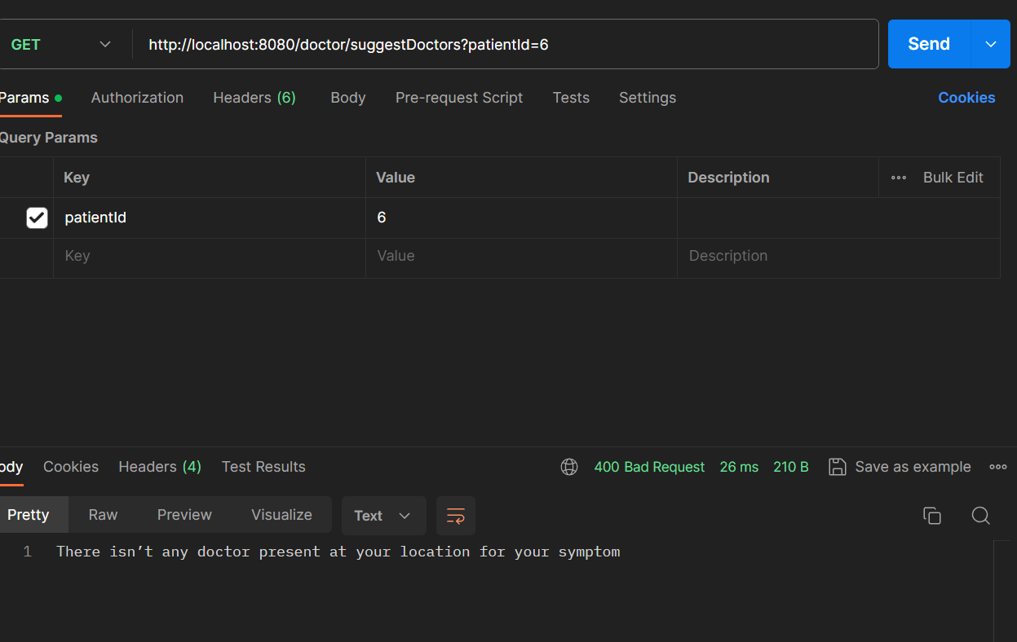

**Suggest doctor which matched with doctor speciality inside that patient symptoms matched, then return doctor information**

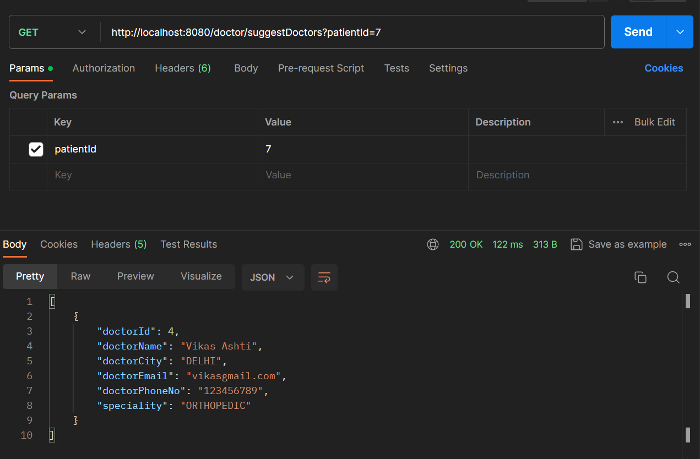**1st Example of correctly running api**

**2nd Example**

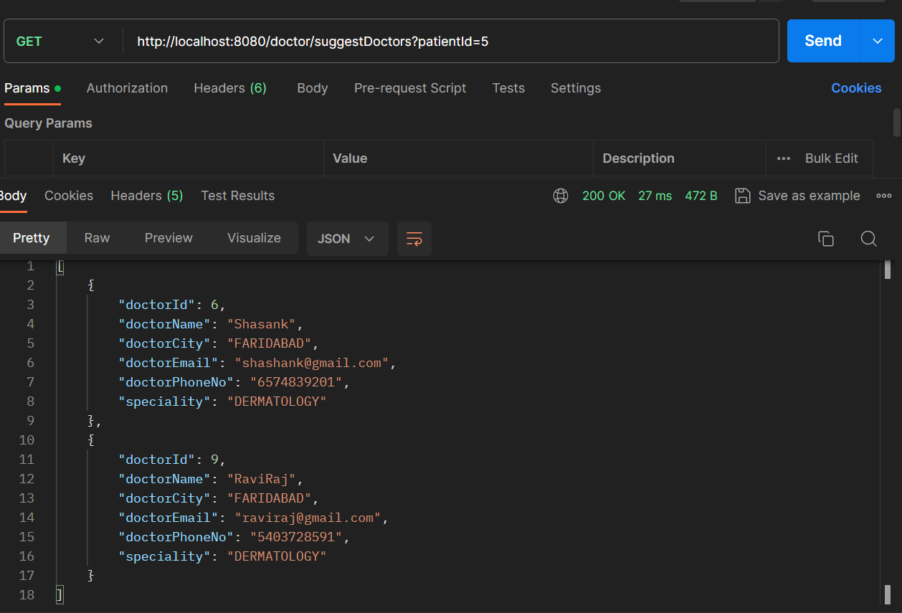

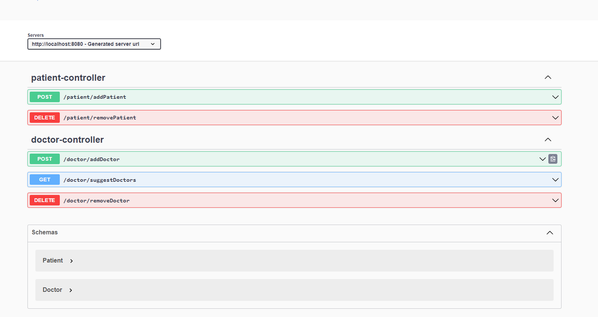 **Swagger UI**

**Link:-**  [**http://localhost:8080/swagger-ui/index.html**](%20http://localhost:8080/swagger-ui/index.html)